Software Delivery Repository
http://downloads.linux.hp.com/SDR/getting_started.html

Getting Started
As this repository contains multiple software products and system targets, it is designed for many types of access modes. This guide will help you get the most from the repository. Essentially there are three major use cases for accessing this repository, as shown in the following figure:

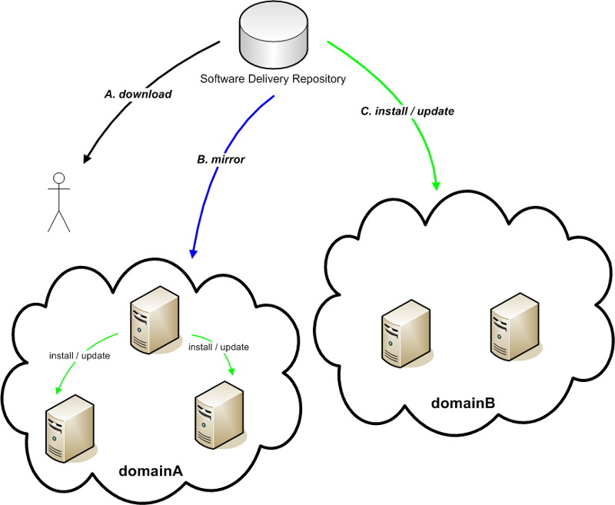

A. Ad-hoc or interactive downloads
At any time, you can access the repository via a browser or command line utility (see repo). If you need only a single component, this may be the preferred way to obtain it. Of course, this means:
- - you will need to carefully pick the applicable component for your use
- - you will have to manually install the component after downloading, and
- - you will need to deal with any install-time dependencies or further updates manually.

B. Mirroring
At your discretion, you may elect to mirror any or all of the repository. This may be preferred due to local networking restrictions or simply to improve network performance for any of your systems which can then install or update from your mirrored copy (see Direct access use case section and related F A Q entries for utilizing your mirror).

Note : Please follow good mirroring and network usage practices, and use efficient tools like rsync or mirror to only transfer what has been updated..

For example you can mirror the contents of the entire repository with the following command:
rsync -av free.linux.hp.com::SDR <MyLocalMirorrPrefix>

C. Direct access install or update
For those systems which can directly access this network repository, you can set them up to query the product (or multiple ones) of your choice. Once configured, these system can track any released updates to those products. To configure this type of access, refer to the following diagram and follow the listed steps:
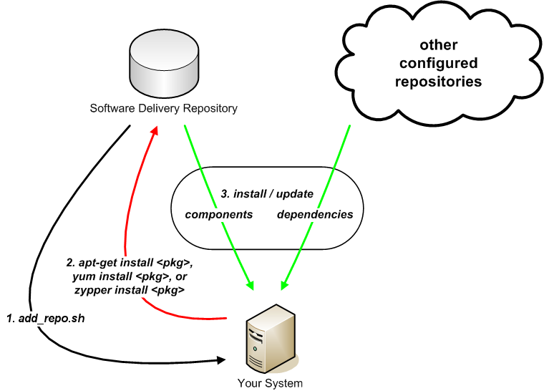

- Obtain the add_repo.sh script and place it on the system you wish to access the repository from.
  - Feel free to review the content of this script to satisfy any security or invocation concerns. If in doubt, feel free to run it as a normal (non-root) user, or in the preview (-n) mode.
  - Make note of the product bundle name you care to install, as shown on the repo page.
  - When ready, invoke the script as the root user:
  - sh ./add_repo.sh <ProductBundleName>
  - as any user with the appropriate options, or refer to the usage information via
  - sh ./add_repo.sh -h
  - If all the prerequisite checks pass, this will deliver the relevant repository access configuration for your specific distribution, version, architecture, and product combination. The resulting configuration can be replicated to any number of similar systems, if you wish.
  - By default, the configuration will point to the currently released set for a given software product. As newer versions become available, your system can track these newer releases (see F A Q entries for ways to only track a particular release)

- At this point, you may use any of the default system tools (like apt-get, yum, or zypper) to query, install, and remove packages from your system based on this repository's contents. As you might expect, this class of tools will download the requested component meta-data from repository indices and calculates the required actions for installation or removal.

- When you install packages, this repository will work in concert with any of your previously configured repositories to resolve dependencies and install in the order dictated by the meta-data indices.

http://downloads.linux.hp.com/SDR/faq.html

Frequently Asked Questions
- Feel free to send email if you find issues or have suggestions for enhancements on this offering.

- The repository does not contain <InsertTypeOfDownload> or something for my particular distribution, version, architecture combination. Why not ?
- There could be a multitude of reasons like:
  - well behaved, binary packages are not yet available
  - the source (or SRPMS) are not being published
  - either the testing has not been completed, or no interest has been shown in the platform to date

- I need to use a proxy to access the repository. How do I set that up ?
- Consult the manual pages of the tool you are using to access the repository (ie. apt-get, yum, zypper) to setup the correct proxy configuration. Of course, you are also welcome to mirror the repository to a local host.

- I have mirrored the repository to my local network. How do I use this from my system?
- You can still utilize the add_repo.sh script, however, you will want to possibly use one or more of the "-m", "-w", or "-u" command line options to specify your mirror's setup.

- I noticed that some packages or indices are signed. How can I verify the signatures of the packages in the repository?
  - For HP signed deliverables, you may follow the instructions on the the HP Linux Code Signing site.
  - For distributions utilizing yum, you may be able to modify the delivered configuration, by selective commenting and uncommenting of the desired lines.
  - For distributions utilizing zypper, you may be to automatically trust and import the key by including the following command-line option:
  - --gpg-auto-import-keys
  - Alternatively, in the top level of the Product's directory, you may find a file named "GPG-KEY-<ProductName>"
  - (eg. GPG-Key-ProLiantSupportPack)
  - Find the corresponding <URLtoGPG-KEYFile>
  - (eg. http://downloads.linux.hp.com/SDR/downloads/ProLiantSupportPack/GPG-KEY-ProLiantSupportPack)
  - for the product of interest, and as root, use it in the following commands:
    - for DEB-based distributions run:
    - wget <URLtoGPG-KEYFile> -O - | apt-key add -
    - and verify via
    - apt-key list
    - for RPM-based distributions, run:
    - rpm --import <URLtoGPG-KEYFile>
    - and verify via
    - rpm -qa gpg-pubkey*
    - then look for an entry containing the string "2689b887" or "2689B887" and associated with the Hewlett-Packard Company.

- I do not want to continually track the "current" released set, but am happy with a particular release of a given product. How do I configure that ?
- In the configuration that was delivered by the "add_repo.sh" script, look for the "current" element of the path, and replace it with the version you prefer to remain at or rerun the "add_repo.sh" script with the desired "-R" argument and value.

- For SLES10 software products, I can't get zypper to see the packages. How do I configure that ?
- On some platforms, it seems you need to still add this as a service for zypper or make YaST aware of the new repository as well. First try:
  - To add a service to zypper, try
  - zypper sa --repo /etc/zypp/repos.d/HP*.repo
  - or perform the following steps within YaST:
  - Software
  - Installation Source
  - Add
  - Specify URL
  - and enter the value of the baseurl from the respective file in
  - /etc/zypp/repos.d/HP*.repo
- For available RHEL4 software products, I don't have yum installed, only up2date, so the add_repo.sh delivers no output. How do I configure up2date ?
- Fortunately, up2date can be manually configured to utilize yum repositories such as this one. Consult your documentation for up2date, and use the following information to guide you:
  - modify the file
  - /etc/sysconfig/rhn/sources
  - add an entry for this respository of the form
  - type channel-label url
  - where
    - type is yum
    - channel-label is something like HP-<ProductName>
    - url is the path you can browse to which contains the <ProductName> and distribution, version, architecture and desired release, for example:
    - http://downloads.linux.hp.com/SDR/downloads/ProLiantSupportPack/RedHat/4/i386/current/

